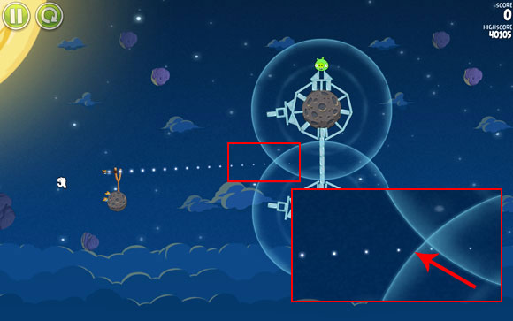

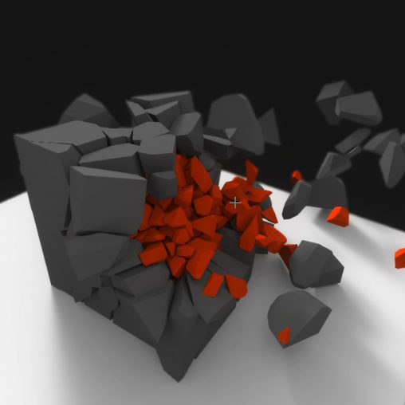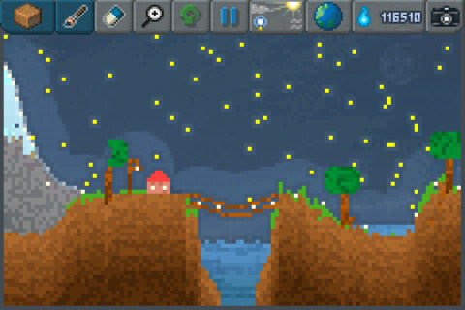

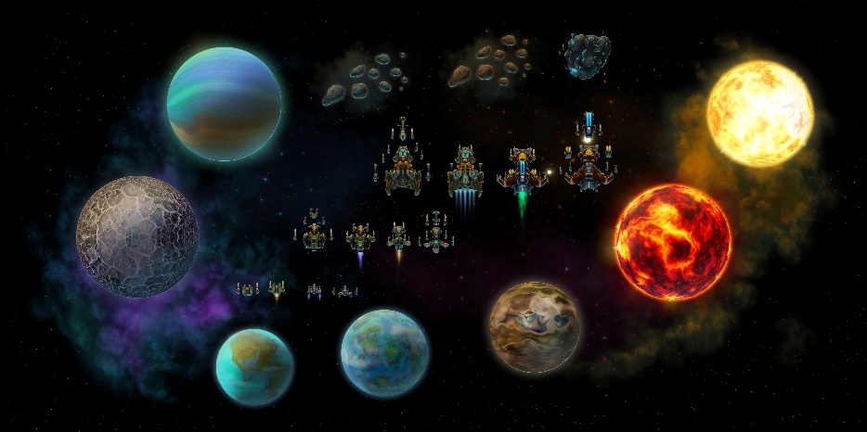

<https://opengameart.org/content/space-game-art-pack-extended>

<https://guides.gamepressure.com/angrybirdsspace/gfx/word/1205738312.jpg>

<https://i0.wp.com/www.rpad.tv/wp-content/uploads/2012/05/Sandbox-2.jpg>

http://thomasdiewald.com/blog/wp-content/uploads/2017/05/Skylight_BulletPhysics_CellFracture_crop-508x508.jpg